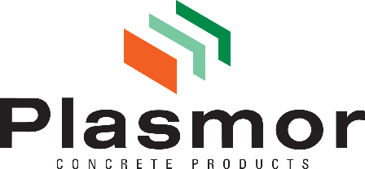

Safeguarding the future

What do we mean by sustainability?
Sustainability is the greatest challenge facing the architectural, building and building supply industries at the moment.
In the construction sector, sustainability is the commitment to plan, design, procure, build, operate and decommission assets in a way that protects the environment, supports people and communities, and delivers long-term economic value.
Considering both operational and embodied carbon, the built environment is responsible for around 40% of global greenhouse gas emissions. The sector carries a responsibility to decarbonise and to transition to resource-efficient, low-impact solutions.

Sustainable construction practices seek to:
- Reduce environmental impact by lowering greenhouse gas emissions, improving energy and resource efficiency, minimising waste and pollution, protecting water and biodiversity, and favouring materials and solutions compatible with a circular economy and climate resilience.
- Deliver social value by ensuring safe and healthy workplaces, fair employment and ethical supply chains, investing in skills and local communities.
- Create durable economic value by optimising whole-life performance rather than short-term cost, improving asset resilience and adaptability, reducing long-term operational and maintenance risks, and strengthening transparent and responsible governance.

For sustainable structures that perform now and in the future, designers, architects and builders should harness the benefits of concrete block construction.
Concrete block construction is the premium building material that satisfies such a demanding criteria. In the clamour to provide huge volumes of new and affordable homes are we overlooking the importance of longevity and legacy in our built environment? Delivering the highest number of houses at minimum cost with low regard for building life expectancy questions the futureproofing of sustainable neighbourhoods and communities. Traditional building methods not ‘pre-fabs’ are the sensible route to providing sustainable buildings, communities and a heritage to be compared to that left to us by our forefathers.

Concrete block is one of the most sustainable building materials in terms of both energies consumed during manufacture and its inherent thermal mass properties in use. The thermal capacity of concrete block structures can be utilised to improve the energy efficiency of buildings. Traditionally built houses have proven abilities to extend maintenance cycles and reduce whole life costs. Economical, reliable, consistent and efficient methods of concrete block construction can deliver cost effective structures, optimise sustainable performance, improve energy efficiency and reduce construction time.

Our commitment to sustainability
Plasmor Ltd is committed to building a sustainable future by reducing our environmental footprint, supporting our people and communities, and delivering long-term value through innovation and responsible operations. We align our priorities with the United Nations Sustainable Development Goals to maximise our positive contribution and manage our impacts responsibly.
We recognise that sustainability is an evolving journey and continually review our operations to ensure we are building long-term, responsible solutions.
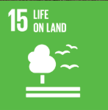
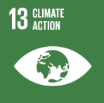
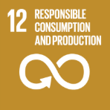
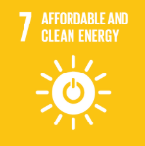
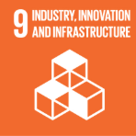
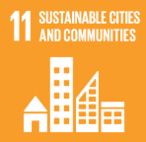
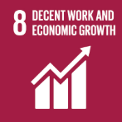

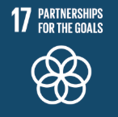

The credentials below reflect our current progress — we have already taken significant steps, and we are committed to going further.

- A proportion of our raw material is an industrial by-product that substitutes the extraction of primary aggregates such as stone, sand, gravel and granite.

- Where primary aggregate is extracted, we use a significant amount of clay which we expand to 5 times its original volume. This represents a significant environmental advantage over alternative virgin quarried aggregates such as stone, sand, gravel and granite. This is because for one tonne of clay quarried, once processed in Plasmor’s unique expanded clay plant, the volume multiplies to five times. Thus 80% less quarried material is required in our manufacturing processes.

- All Plasmor production plants are strategically close to traditional sources of raw materials thus precluding long road transfer of materials.

- Where raw material journeys of 40+ miles are necessary, wherever possible, rail and inland waterway transport is utilised.

- All Plasmor production plants and distribution depots are strategically situated close to densely populated conurbations which constitute the key markets for our products thus minimising LGV lorry movements.

- Plasmor is committed to the continuing use of rail transport. 18% of Plasmor finished product is delivered daily by rail transport thus reducing LGV lorry movements by up to 50 per day.

- Plasmor is committed to the continual investment in and modernisation of its LGV fleet. All replacement vehicles are specified and equipped to the latest European Emissions Standards.

- All waste/reject materials derived from the production process are recycled and re-used in production with nil concrete waste to landfill.

- The use of alternative fuels including waste and re-cycled materials is maximised in the generation of heat and power for the Company’s consumption.

- Throughout the Company, all energy generation and product curing equipment is being systematically replaced or modernised with the very latest sophisticated energy efficient equipment.

- The Company is committed to driving a sustainable future by investing in renewable energy, reducing environmental impact while supporting innovation and long-term operational resilience.

- Plasmor products are presented to market with minimal packaging. All packaging materials are biodegradable or recyclable.

- Continual research and development is undertaken into new product development, the use of environmentally benign materials, energy conservation and the use of alternative waste and recycled fuel sources.

- New product development with an emphasis on embodied carbon content, satisfying sustainability and environmental credentials where specified, whilst complying with Building Regulations.

- The Company is committed to reducing paper use by adopting digital solutions wherever possible. When paper is necessary, we ensure it is FSC certified to support sustainable forestry practices and responsible resourcing

- Supply chain management secures raw materials and equipment from environmentally sensitive suppliers and from renewable sources where possible. We commit to sourcing materials from suppliers with efficient, low-impact production processes, verified sustainability practices, and ethically responsible sourcing.

- In the interest of good neighbourliness and Health and Safety best practice, the Company is committed to monitoring and maximising air and noise suppression.

Plasmor remain at the forefront of innovative sustainable construction materials with concrete blocks at the forefront of sustainable, long-lasting construction.

